LESSON 11.1

Find the Total Coin Value
Go Online
Interactive Examples
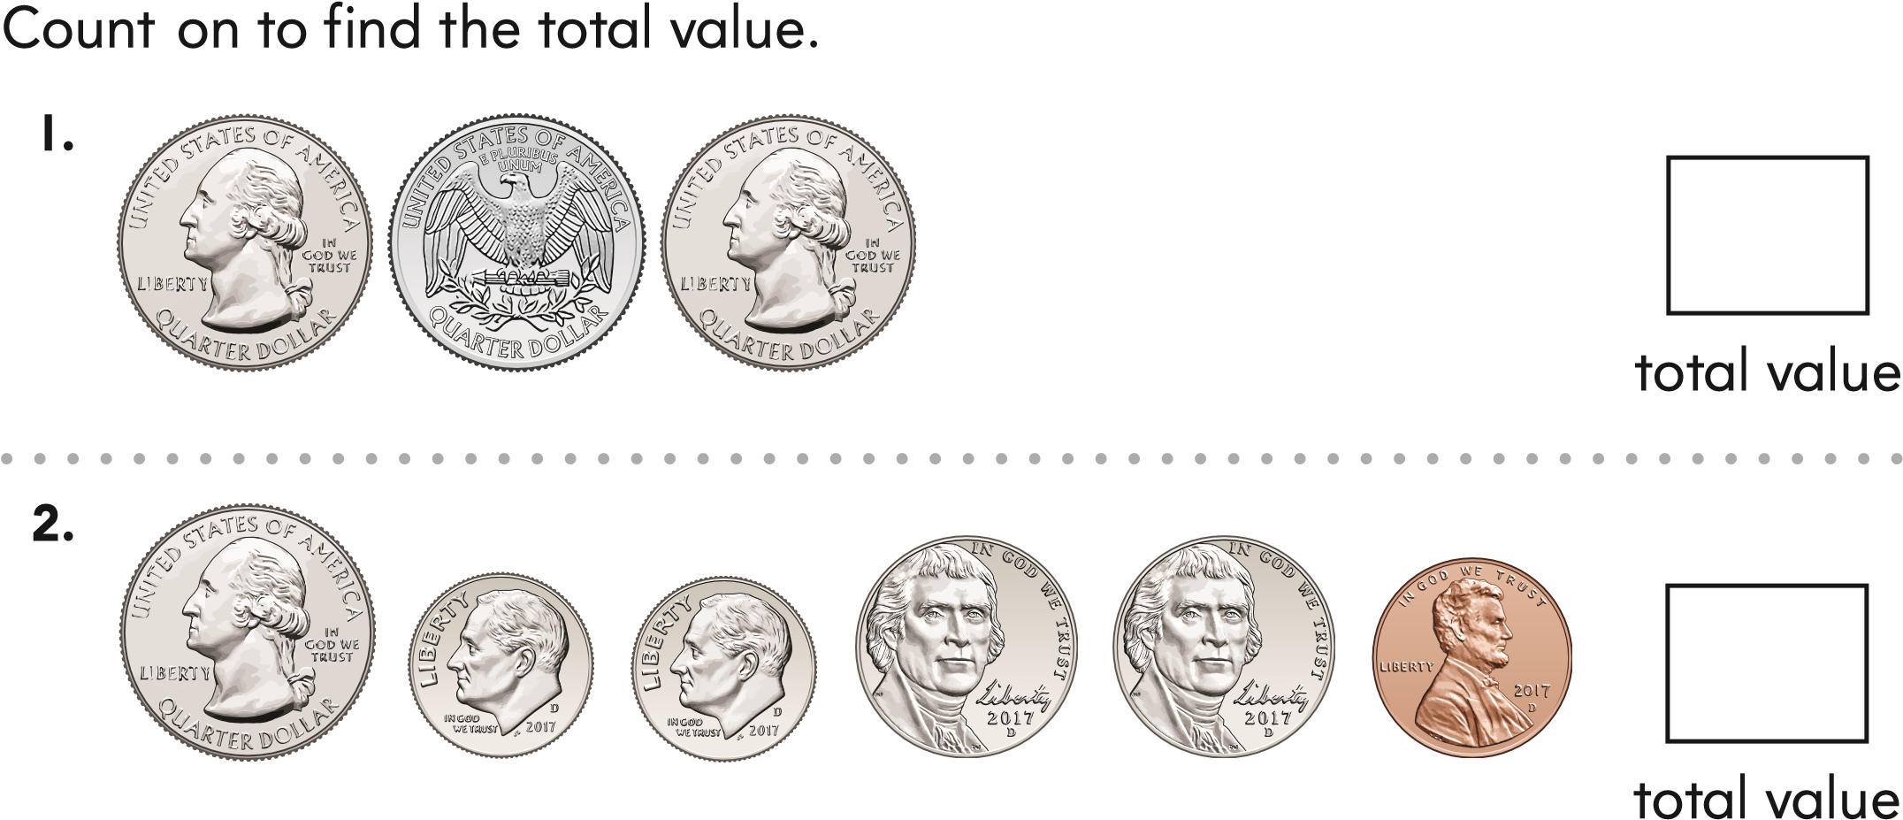
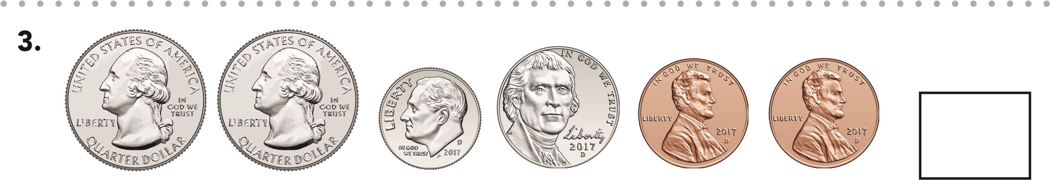
total value
© Houghton Mifflin Harcourt Publishing Company
Chapter 11 • Lesson 1
421
Draw and label coins to solve.
Problem Solving
4.
Imelda has two different groups of coins that each have
a total value of 40¢. There is at least one quarter in
each group. What coins could she have?
Choose the correct answer.
5. Levi gives these coins to his sister. How much money does Levi give to his sister?
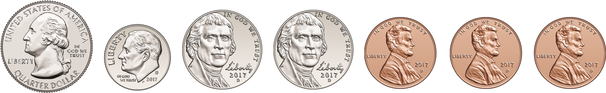

● 48¢ ● 43¢ ● 58¢

6. Kelly uses 2 quarters and 1 dime to buy a banana. How much money does the banana cost?

● 50¢ ● 80¢ ● 60¢

7. Ming has 75 cents. Ming has 50 cents more than Kayla. How much money does Kayla have?
© Houghton Mifflin Harcourt Publishing Company
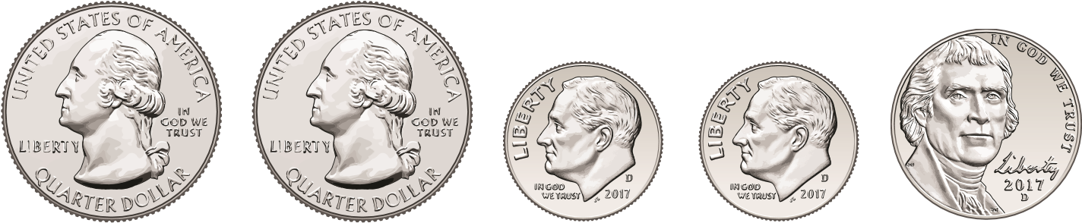

● 55¢ ● 25¢ ● 50¢

Spiral Review
8. Tamra has 23 cards. Ming has 64 cards. How many more cards do they need to have 90 cards altogether?

● 41 ● 3 ● 1
422
LESSON 11.2

One Dollar
Go Online
Interactive Examples
Circle coins to make $1. Cross out the coins you do not use.
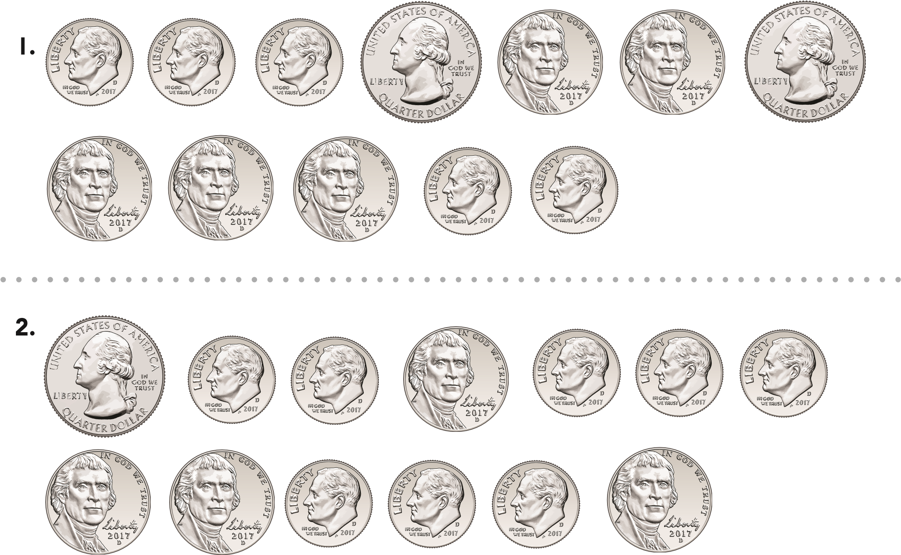
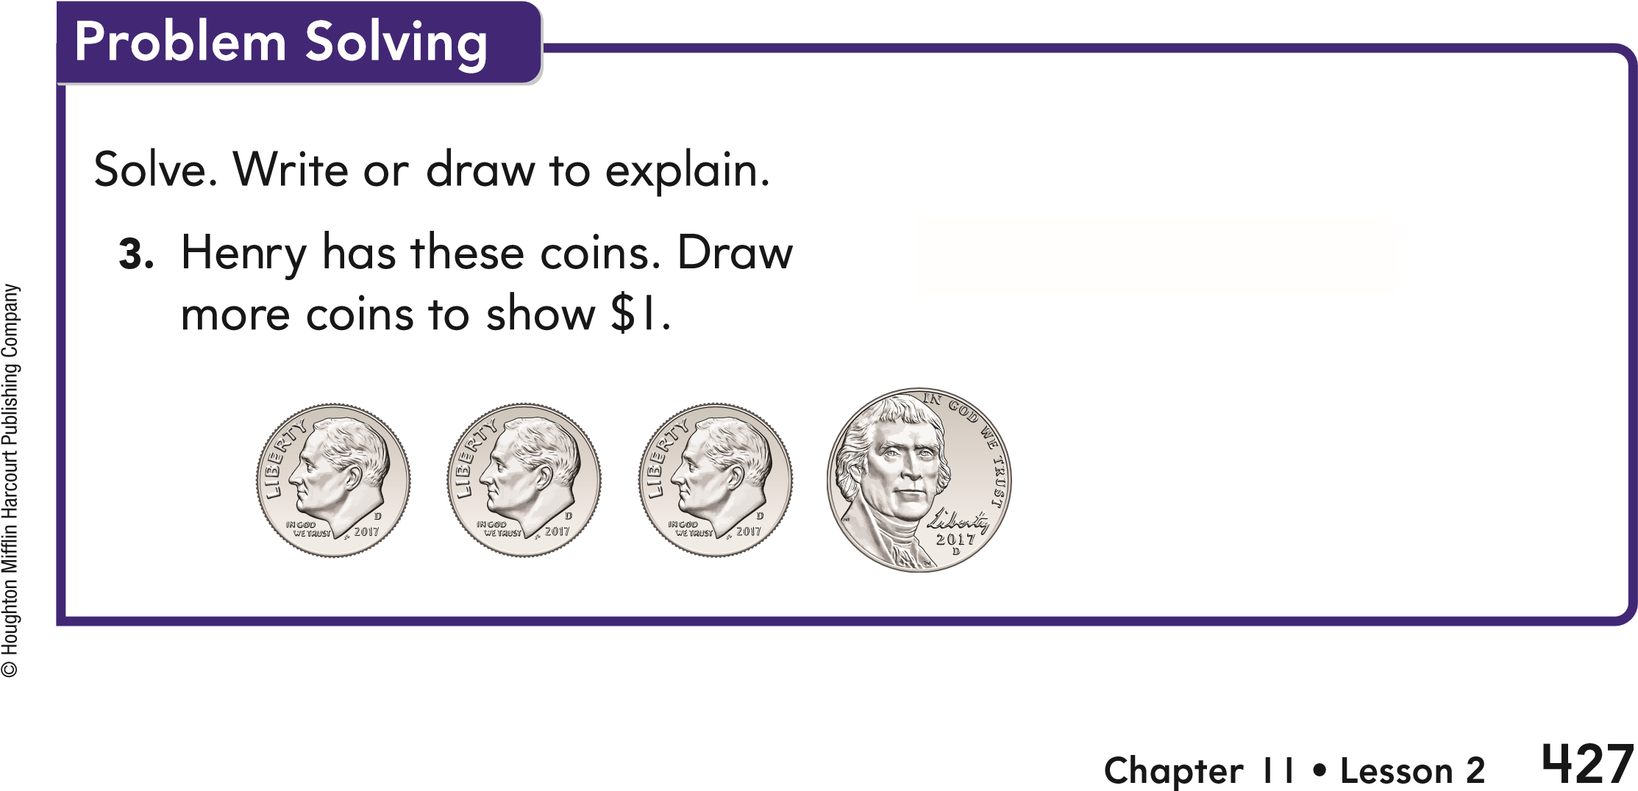
Choose the correct answer.
- Scott has these coins. Which coin does he need to show $1?
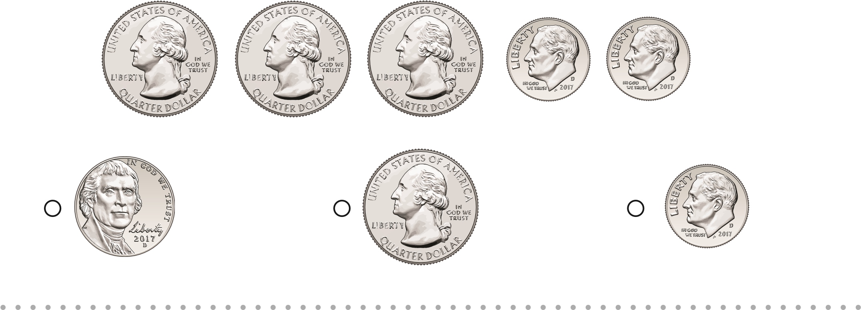
- C arlos has 86¢. Carlos has 14¢ less than Hugo.
How much money does Hugo have?

● $100 ● 72¢ ● $1

Spiral Review
6. Which represents the number four hundred nine?
© Houghton Mifflin Harcourt Publishing Company
428

●
419
●
409
●
490
7.
Which shows 549 rounded to the nearest hundred?
●
500
●
600
●
550
LESSON 11.3

Compute the Value of Dollar
Go Online
Combinations Interactive Examples
Write the total value.
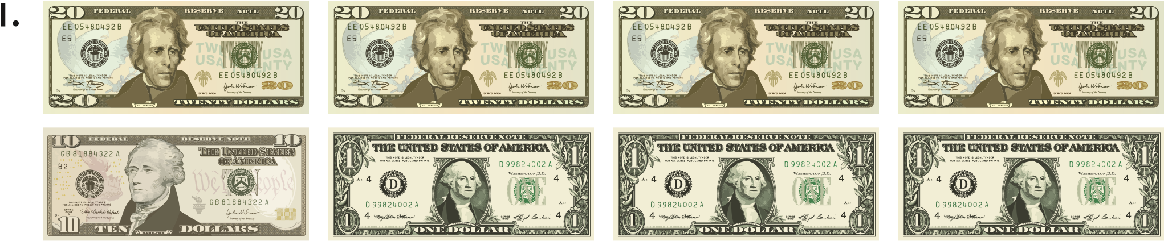
—
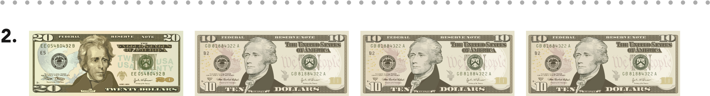
© Houghton Mifflin Harcourt Publishing Company
Chapter 11 • Lesson 3
433
—

Solve. Write or draw to explain.
3.
Andy has only $20 bills and $5 bills. The total
value of his bills is $65. What bills could
Andy have?
Problem Solving
—

$20 bills
—

$5 bills
Choose the correct answer.
- M r. Blanco has these bills. Mrs. Cabrera has $25. They buy party supplies for $54. How much money will they have left?
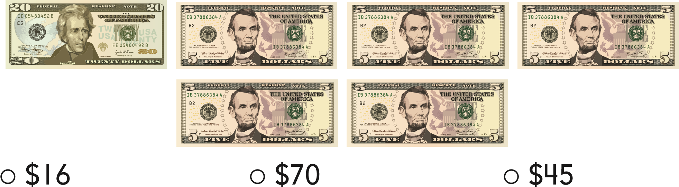

- Yee has some bills. Then his foster mom gives him $24. He now has $38. How much money did he start with?

● $52 ● $62 ● $14

Spiral Review
6. Jan’s mother gives Jan these coins. How much did she give Jan?
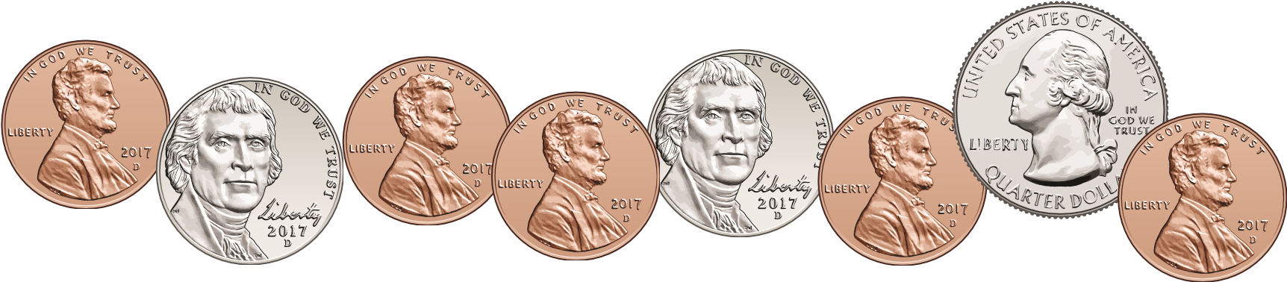

● 55¢ ● 40¢ ● 60¢
7. Steve has some coins in his bank. He needs 2 dimes to make a dollar. What is the value of the coins in Steve’s bank?
© Houghton Mifflin Harcourt Publishing Company

● 80¢ ● 90¢ ● 75¢
434
LESSON 11.4

Solve Problems Involving Money
Go Online
Interactive Examples
Use coins to solve the problem. Draw to show what you did.
1. Trish has 5 pennies, 1 dime, and 3 quarters. She wants to buy a headband that costs 69 cents. How much money will she have after she buys the headband?
Trish has — after she buys the headband.
© Houghton Mifflin Harcourt Publishing Company
Chapter 11 • Lesson 4
439
Solve. Write or draw to explain.
Problem Solving
2.
Jeff uses nickels and pennies to
buy a pencil that costs 39¢.
What coins could Jeff use to buy
the pencil?
—

nickels
—

pennies
3.
Mrs. Cheng uses two $20 bills, one
$10 bill, one $5 bill, and three $1 bills
to buy food at the grocery store. How
much money does Mrs. Cheng spend
at the grocery store?
—

Choose the correct answer.
4. H an saves three $10 bills and three $5 bills. Then he saves three more $5 bills. How much money does Han save?

● $60 ● $20 ● $30

- L illy finds three coins at the park. The total value of the coins is 60¢. What three coins does she find?
  - 3 quarters
  - 2 quarters, 1 dime
  - 2 quarters, 1 nickel

- R osa pays $67 for camping supplies. Mai Neng pays $15 more for her camping supplies. How much did Mai Neng pay for her supplies?

● $72 ● $52 ● $82

Spiral Review
- A number can be represented by two equal groups. Is it even or odd? Given an example.
© Houghton Mifflin Harcourt Publishing Company
——————
- 946 = — hund reds + — t ens + — one s
440

